1)Draw a flowchart to accept number and check it is positive or negative

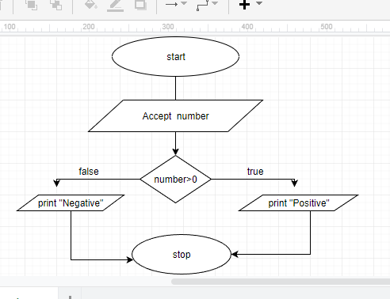

2) Draw a flowchart to accept number and check it is Even or Odd.

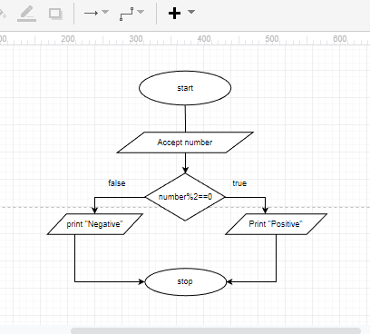

3)Draw a flowchart to accept age from user and print he/she is eligible for voting or not.

